23-2-25

Join in Database

1- Cross Join:   
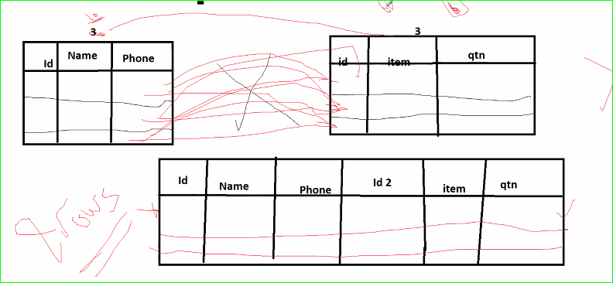  
  
Cross Join

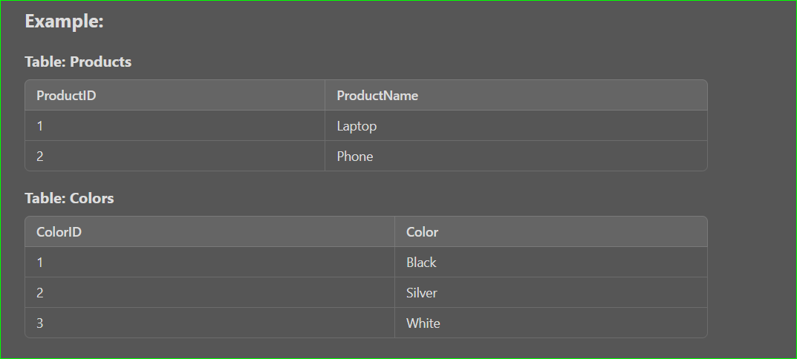  
  
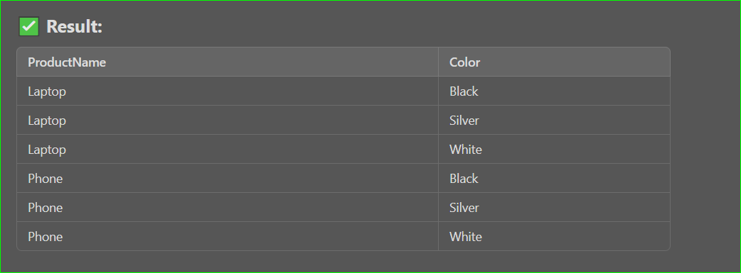  
  
2) inner join